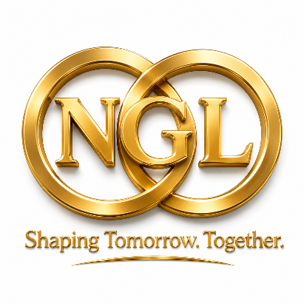

Place Matters
  - Strengthening places. Empowering communities. Shaping the future.
An initiative of Next Generation Local (NGL), developed to support stronger places, stronger communities and the future of local governance in Aotearoa New Zealand.
Every place has a story. Every community has strengths. Every generation deserves a say in the future they inherit.
Place Matters is for people who believe communities should have a real voice in shaping the places they call home.
It is for everyone who calls a place home: tangata whenua, long-standing residents, newcomers, young people, older people, disabled people, rural communities, urban neighbourhoods, migrant communities, workers, families, businesses and people whose voices are too often missing from decisions.
If you care about your place and its future, join us.

Part 1: The Movement

Place Matters at a glance
What is Place Matters?
Place Matters is a national civic movement for people and organisations who believe every community should have a stronger voice, stronger local democracy and a fairer chance to shape its future.
Why now?
Aotearoa New Zealand faces major choices about infrastructure, housing, public services, local democracy, economic transition, climate resilience and community wellbeing. These choices will work best when they are shaped with places, not simply done to them.
Who is it for?
Place Matters is for everyone who calls a place home: tangata whenua, long-standing residents, newcomers, young people, older people, disabled people, rural communities, urban neighbourhoods, migrant communities, workers, families, businesses, councils, public agencies, schools, universities and civil society organisations.
The six principles
Place matters. People have a voice. Local democracy matters. Partnership creates better outcomes. The future must be protected. Principles must become action.
How we measure success
Beyond GDP: wellbeing, trust, resilience, participation, public service quality and ecological responsibility.
How we act
Through participatory budgeting, community empowerment, local evidence platforms, shared outcome dashboards, pilot places and shared learning.
How to join
Start where you are: sign on, tell your place story, start a local conversation, share evidence and examples, back a pilot place, or champion the movement.
What we want to change
Place Matters aims to move Aotearoa New Zealand from fragmented governance to partnership governance, from consultation to co-creation and empowerment, from short-term fixes to long-term stewardship, and from one-size-fits-all policy to solutions shaped by each place.
Join us if you believe strong places build a strong Aotearoa New Zealand.

Why Place Matters
Places are where life happens. They are where people live, work, care, learn, grow food, build businesses, protect the environment, raise families, share culture and make decisions about the future.
When places are strong, people feel heard and included, services work better, investment is better aligned, local identity is valued, and communities are better prepared for change.
The question is not simply whether reform is needed. It is whether the choices we make now strengthen or weaken the ability of regions, towns, cities, rural communities and neighbourhoods to shape their own future.

The Place Matters Movement
Place Matters is a national civic movement grounded in a simple belief: prosperity begins in places, and decisions are better when they are shaped with communities, not simply done to them.
It brings together tangata whenua, councils, communities, rangatahi, older people, disabled people, rural and urban communities, migrant communities, businesses, public agencies, researchers, educators and civil society to build trust, share evidence, lift local stories and test practical reforms.
Infrastructure matters, but it is never enough on its own. Strong places are built when leadership, partnership, local knowledge, public service quality and long-term stewardship work together.
Its aim is a living civic movement that connects local voice, democratic authority, public service quality, ecological responsibility, futures thinking and practical action.

The six movement principles
- Place matters. Prosperity, wellbeing, resilience, identity and belonging are created in real places.
- People have a voice and influence. Communities should help shape the decisions, budgets, services and investments that affect their lives through inclusive, accessible and culturally safe participation, with empowerment built over time.
- Local democracy matters. Local government should have the authority, capability and resources to act with and for its communities.
- Partnership creates better outcomes. Central government, local government, tangata whenua, communities, business and civil society should work together around shared place outcomes.
- The future must be protected. Decisions should respect ecological limits, prepare for change and protect the wellbeing of future generations.
- Principles must become action. Place-based governance should lead to practical tools, shared investment, better services, visible learning and measurable outcomes.

What we commit to
People and organisations who join Place Matters commit to six practical ways of working:
- Listen to the voice of place by respecting local identity, history, relationships, knowledge, lived experience, culture, language and aspirations, especially voices that are often less heard.
- Work together across boundaries so councils, central government, tangata whenua, communities, business, public agencies and civil society act around shared outcomes.
- Strengthen local democracy by supporting local self-government, local choice, local leadership and fair alignment between responsibilities, powers, capability and resources.
- Protect the future by using foresight, scenarios, intergenerational testing and ecological limits to guide decisions.
- Build trust through better public services by supporting reliable, accessible, culturally responsive and accountable services.
- Turn principles into action through place partnership agreements, shared asset and investment plans, participatory budgeting, local evidence platforms, pilot places and regular review.

How to join
You do not need to wait for permission to join. Start with one conversation, one story, one partnership, one pilot or one action in your own place. Every contribution can help build the movement.
- Sign on as an individual, organisation, council, community group, business, school, university, iwi or public agency that believes place matters.
- Tell your place story by sharing what makes your place distinctive, what challenges it faces, what people value and what future you want to build together.
- Start a local conversation with residents, tangata whenua, rangatahi, older people, disabled people, community organisations, migrant communities, businesses and local leaders.
- Share evidence and examples of place-based leadership, community partnership, local innovation, resilience, public service improvement or collaborative investment.
- Back a pilot place by helping test practical tools such as place partnership agreements, shared outcome dashboards, participatory budgeting, local evidence platforms or youth and rangatahi assemblies.
- Champion the movement by promoting the Charter, convening partners, encouraging local action and connecting places with national and international learning.

What happens next?
Place Matters will grow through local conversations, pilot places, shared learning, public stories and practical reforms. It will keep asking: what does each place need, who needs to be at the table, and what future are we prepared to build together?
Place Matters starts with one place, one conversation and one shared commitment to build a stronger future together. Join Place Matters. Tell your place story. Help build the next generation of local governance.

Part 2: The Charter

Aotearoa New Zealand Charter for Place-Based Governance
Preamble
The prosperity and resilience of Aotearoa New Zealand depend on the strength, confidence and capability of its places. Effective governance requires strong local self-government, shared purpose between national and local leadership, tangata whenua partnership, community voice, business capability and civil society action, so places have the democratic authority, resources and capability to thrive, adapt, innovate and build long-term wellbeing.
- Place matters
Policy should recognise that prosperity, wellbeing, resilience, identity and belonging are created in places.
- Shared place purpose
Partners should work together around a clear, locally grounded vision for services, infrastructure, investment, environment, resilience and community wellbeing.
- Shared stewardship of services, land, infrastructure, investment and public assets
Partners should plan, use and care for services, land, infrastructure, investment and public assets together, so public and community resources support long-term wellbeing, resilience, local identity, environmental responsibility and fair access across generations.
- Tangata whenua partnership
Place-based governance must recognise tangata whenua relationships with place and support partnership, shared stewardship, mātauranga Māori and long-term responsibility.
- Local self-government and subsidiarity
Local government should have clear democratic authority, responsibilities, capability and resources to act on behalf of its communities. Decisions should be made at the most local effective level, with national government setting clear outcomes, enabling local choice and respecting the role of councils as accountable democratic institutions.
- Inclusive places
Every person should have the opportunity to participate in shaping their community, regardless of culture, ethnicity, place of origin, language, age, ability, income, faith, identity or background.
- Participation and empowerment by design
Communities should help shape priorities, options, budgets and trade-offs early, not simply be consulted after decisions are largely formed. Participation should build capability, confidence and shared authority over time.
- Evidence, local knowledge and data sovereignty
Places should be supported to use local evidence, national evidence, community knowledge and Māori data governance in ways that are transparent, ethical and trusted.
- Trust, transparency and public service quality
Public services should be reliable, accessible, timely, culturally responsive and accountable. Places should use clear service standards, transparent reporting and community feedback to strengthen trust in public institutions.
- Outcome-based governance and beyond GDP
Success should be measured by results that matter to people and places, including wellbeing, resilience, fairness, environmental quality, natural capital, community wealth, productivity, trust, participation and public service quality, while recognising ecological limits and the need to protect the life-supporting systems that future generations depend on.
- Fair funding, authority and capacity
Funding, powers, responsibilities and capability should be aligned so local authorities and their partners can deliver agreed outcomes in a financially responsible and locally fair way, without shifting unfunded responsibilities onto communities or councils.
- Learning places
Places should be able to test, learn, adapt and scale what works, supported by evidence, peer learning and honest review.
- Future readiness
Governance systems should use foresight, scenarios, prevention, intergenerational testing and adaptive review to anticipate climate, demographic, economic, technological, environmental, health and social change, strengthen resilience, support innovation and protect the wellbeing of present and future generations.
- Principles into practice
Each Charter principle should be connected to clear ways of working, shared responsibilities, funding pathways, measurable outcomes and regular review.

Call to Action
Government, councils, tangata whenua, communities, business, universities, schools and civil society are invited to co-create, test and refine this Charter through place-based pilots, participatory budgeting, community empowerment, shared outcome dashboards, public learning, national and international knowledge exchange, foresight, scenarios and intergenerational testing.
Together, we can shape places that are resilient, inclusive, democratic, prosperous and ready for the future by using foresight, scenarios, adaptive learning and intergenerational stewardship to protect wellbeing, trust, public service quality, opportunity and ecological responsibility for generations to come.

Part 3: The Framework for Action

The strategic opportunity: building future-ready places
Place-based reform should begin with the future Aotearoa New Zealand wants to build: thriving communities, resilient services and infrastructure, trusted democratic institutions, strong tangata whenua partnerships, inclusive local economies, healthy environments and a wellbeing economy that values social, cultural, environmental and economic outcomes alongside productivity.
This Charter encourages long-term, preventative, integrated and collaborative ways of working that enable participation and empowerment. It asks partners to imagine, design, test and sustain the futures their places need, while learning from national and international practice. This framework supports localising shared global goals, including the Sustainable Development Goals, leaving no one behind, human rights-based participation, Indigenous rights, resilience and intergenerational equity through practical place-based action.

Strategic spatial planning
Strategic spatial planning helps places understand how housing, transport, infrastructure, land use, climate risk, public services, economic development, environmental limits and community wellbeing interact across towns, rural areas, regions and catchments.
It supports better decisions by showing the long-term consequences of where people live, how they move, where infrastructure is placed, how land and water are used, how services are accessed, and how places can adapt to climate, demographic, economic and environmental change.
Place-based governance should use strategic spatial planning to connect local evidence, mātauranga Māori, community priorities, investment choices, ecological limits and future scenarios in a single view of place. This helps partners see trade-offs clearly, reduce inequalities between places, and plan for inclusive, resilient and sustainable futures.
Strategic spatial planning turns the Charter’s principles into a shared map of action: where growth should occur, where protection is needed, where investment should be aligned, and how each place can prepare for the future.

Futures thinking and intergenerational stewardship
Future-ready places do not wait for change to arrive before responding. They use foresight, scenarios, local evidence, mātauranga Māori, lived experience and intergenerational dialogue to anticipate change, test choices and prepare for uncertainty.
Futures thinking helps partners look beyond immediate pressures and ask what different decisions will mean for climate risk, housing, infrastructure, water, biodiversity, public services, local economies, culture, social cohesion and democratic trust over decades, not just election cycles or funding rounds.
Each place should be supported to explore plausible futures, identify risks and opportunities, test whether decisions are fair across generations, and adjust plans as conditions change. This includes preparing for climate, demographic, economic, technological, environmental, health and social shocks.
Used well, foresight and scenarios help places make choices that remain fair, resilient and adaptable over time.

Why place matters
Places are where national goals become real. Housing, transport, climate adaptation, economic development, public health, education, culture, infrastructure, environmental care and democratic participation all meet in particular communities with particular histories, assets, risks and aspirations.
Successful regions show what is possible when councils, iwi and hapū, businesses, universities, community organisations and central government align around shared goals. Infrastructure matters, but leadership, trust and sustained partnership make change possible.
Strong places need strong local institutions, community confidence, social licence and long-term stewardship. They also need national settings that enable local flexibility, fair capacity and coordinated investment.
Councils are not simply service delivery organisations. They are place leaders. They convene partnerships between iwi, hapū, business, central government and communities, coordinate investment, enable development and help shape the conditions in which prosperity, wellbeing and trust emerge.

Shared national missions
Place-based governance should focus on shared missions that no single agency, council, iwi, business or community can solve alone. These missions need national direction, local knowledge, tangata whenua partnership, community influence, fair funding and coordinated delivery.
Prosperous places are created when infrastructure, leadership, collaboration, community empowerment, innovation and local knowledge are aligned around a shared vision of the future.
- Resilient communities and climate-ready infrastructure
- Affordable, healthy homes and connected neighbourhoods
- Healthy environments, biodiversity and sustainable land and water use
- Inclusive local economies and decent work
- Trusted local democracy and meaningful public participation
- High-quality, reliable and accessible public services that strengthen trust in institutions
- Social licence for change and investment
- Readiness for long-term transitions, including climate, demographic, infrastructure and technological change
- National and international knowledge exchange that can be adapted to local conditions

A future-ready place-based governance model
- Tangata whenua partnership and stewardship: place-based governance in Aotearoa New Zealand must recognise tangata whenua relationships with place and support partnership, shared authority, mātauranga Māori and long-term responsibility.
- Subsidiarity and local flexibility: decisions should be made at the most local effective level, with national government setting clear outcomes and enabling places to choose approaches that fit their circumstances.
- Shared stewardship of assets and investment: partners should work together to plan, use and care for services, land, infrastructure, investment and public assets so they support long-term wellbeing, resilience, local identity and environmental responsibility.
- Participation and empowerment by design: communities should help shape priorities, options, budgets and trade-offs early, through practical processes that build trust, transparency, capability and shared responsibility.
- Evidence, local knowledge and Māori data governance: decisions should draw on national evidence, local evidence, community knowledge and Māori data governance, with clear protection for information that communities and tangata whenua hold.
- Outcome-based accountability: success should be measured by results and learning, not compliance alone. Measures should include wellbeing, resilience, fairness, environmental quality, natural capital, community wealth, trust and participation.
- Trust, transparency and public service quality: public services should be reliable, accessible, culturally responsive and accountable, with transparent decisions and delivery standards that strengthen public trust.
- Fair funding and capacity: funding, responsibility and capability should be aligned so places can deliver agreed outcomes without shifting unfunded responsibilities onto communities or councils.
- Learning and adaptation: places should be able to test, learn, adapt and scale what works, supported by transparent evidence, peer learning and review.
- Foresight and intergenerational testing: places should use scenarios, long-term evidence and future generations assessments to test whether today’s decisions remain fair, resilient and adaptable under different future conditions.
- Future generations: decisions should protect the wellbeing, resilience, voice and opportunities of young people and future generations.

How it works
Place Partnership Agreements set shared missions, outcomes, roles, funding responsibilities and review points for a place.
Shared asset and investment plans help partners align services, land, infrastructure, investment and public assets with local priorities, long-term stewardship and agreed place outcomes.
Shared outcome dashboards show progress on wellbeing, resilience, trust, environmental quality, natural capital, community wealth and local economic outcomes.
Public service quality measures track whether services are reliable, accessible, timely, culturally responsive and trusted by the communities they serve.
Local evidence platforms bring together national data, local evidence, community knowledge and tangata whenua expertise to support better decisions.
Deliberative participation uses citizens’ assemblies, community panels, local forums and workshops so people can shape priorities and trade-offs before decisions are finalised.
Participatory budgeting gives communities a direct and transparent role in shaping selected investment choices, helping align public spending with local priorities and social licence.
Youth and rangatahi voice is built into place-based decisions through youth assemblies, school forums, rangatahi forums and future generations panels.
Iwi and Māori-led processes support tangata whenua partnership, shared stewardship, mātauranga Māori and long-term responsibility for place.
Pilot places and learning loops test new approaches, review what works, adapt what does not, and share lessons openly.
Regular review keeps long-term assumptions, funding settings and delivery responsibilities fit for changing conditions.
Futures and scenarios help partners anticipate change, test major choices against different future conditions, and avoid locking places into decisions that increase long-term risk.
Knowledge exchange connects New Zealand places with leading practice from Aotearoa and overseas, so ideas can be adapted locally and shared through communities of practice.

The place dividend
The Place Dividend is the public value created when local knowledge, shared investment, community participation and long-term stewardship are aligned around the future of a place.
It should be measured through a beyond-GDP lens, including wellbeing, resilience, fairness, environmental quality, cultural wellbeing, natural capital, community wealth, productivity, trust, participation, public service quality and quality of life, while recognising ecological limits. The purpose is to help each place tell a clear public story about progress, risks, service performance, environmental thresholds and choices.
The Place Dividend arises from alignment, community empowerment and shared stewardship. It is expressed through stronger local economies, better environmental outcomes, stronger local leadership, greater resilience, higher trust in institutions and improved quality of life.
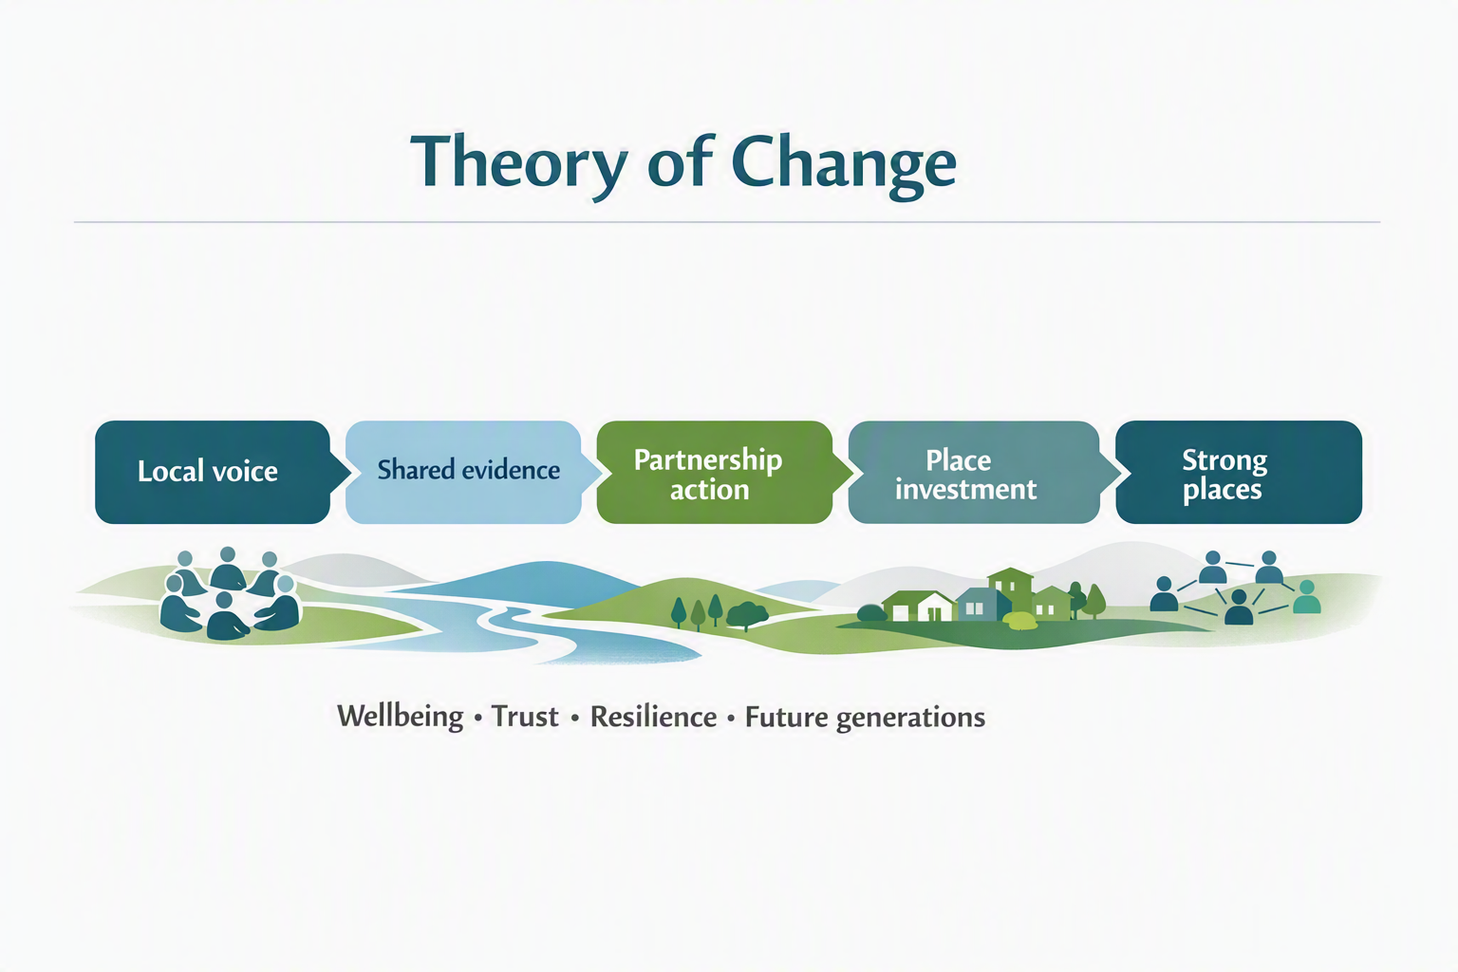

From Charter to Action
The Charter becomes real when places move from shared principles to practical action: sign on, start a local conversation, identify a pilot place, build local evidence and shared outcome dashboards, test tools such as participatory budgeting, strengthen community empowerment, review what works, and scale learning through national and international exchange.

Turning principles into practice
- Connect principles to delivery. Each principle should be linked to practical ways of working, clear roles, funding pathways, measurable outcomes and regular review.
- Explain funding pathways clearly. Funding pathways should show who contributes, what outcomes the funding supports, what responsibilities sit with each partner, and when progress is reviewed.
- Align funding with outcomes. Funding should support agreed wellbeing, resilience, environmental and economic outcomes, not activity for its own sake.
- Put partnership into practice. Place Partnership Agreements can bring partners together around shared outcomes, roles, delivery responsibilities, funding and review.
- Put participation and empowerment into practice. Citizens’ assemblies, community panels, participatory budgeting, deliberative workshops and local conversations can help communities shape priorities, build confidence and influence decisions early.
- Use pilots to learn. Pilot places can test approaches such as youth participation, Māori data governance, participatory budgeting and shared outcome dashboards before wider rollout.
- Review before scaling. Major decisions, pilots and partnership agreements should include review points so partners can adjust as conditions change.

Conclusion: Building the Next Generation of Local Governance
Place Matters is an invitation to build a stronger future from the ground up. It connects local voice, tangata whenua partnership, democratic authority, community empowerment, evidence, foresight and shared stewardship so that places can shape the futures they need.
The Charter sets out the principles. The Framework for Action shows how those principles can become practical change through local conversations, pilot places, participatory budgeting, shared outcome dashboards, local evidence platforms, strategic spatial planning, national and international learning, and regular review.
As an initiative of Next Generation Local, Place Matters provides a way to bring people, institutions and communities together around a shared belief: strong places build a strong Aotearoa New Zealand.
The next step is practical and local: start a conversation, tell a place story, back a pilot, share evidence, build partnerships and help turn the next generation of local governance into reality.
Place matters because people, communities and future generations matter.

References
Architecture and Design Scotland. (n.d.). The Place Principle. https://www.ads.org.uk/place-principle
Council of Europe. (n.d.). The European Charter of Local Self-Government: How it works. https://www.coe.int/en/web/congress/the-charter-how-it-works
European Commission. (2021). Territorial Agenda 2030: A future for all places. https://ec.europa.eu/regional_policy/information-sources/publications/brochures/2021/territorial-agenda-2030-a-future-for-all-places_en
European Union. (2020). Territorial Agenda 2030: A future for all places. https://territorialagenda.eu/
Future Generations Commissioner for Wales. (n.d.). How we work: The five ways of working. https://futuregenerations.wales/do/how-we-work/
GOV.WALES. (2015). Well-being of Future Generations (Wales) Act 2015: The essentials. https://www.gov.wales/well-being-future-generations-act-essentials-html
Nordic Co-operation. (n.d.). Public service delivery in the Nordic Region: An exercise in collaborative governance. Nordic Council of Ministers. https://www.norden.org/en/publication/public-service-delivery-nordic-region-0
Nordic Council of Ministers. (2024). A beyond-GDP view of Nordic performance. https://pub.norden.org/temanord2024-560/temanord2024-560.pdf
Organisation for Economic Co-operation and Development. (n.d.). Multi-level governance. https://www.oecd.org/en/topics/multi-level-governance.html
Organisation for Economic Co-operation and Development. (2020). OECD guidelines for citizen participation processes. https://www.oecd.org/en/publications/oecd-guidelines-for-citizen-participation-processes_f765caf6-en.html
Organisation for Economic Co-operation and Development. (2023). Recommendation of the Council on Regional Development Policy. https://legalinstruments.oecd.org/en/instruments/OECD-LEGAL-0492
Organisation for Economic Co-operation and Development. (2023). Place-based policies for the future. https://www.oecd.org/en/publications/place-based-policies-for-the-future_e5ff6716-en.html
Organisation for Economic Co-operation and Development. (n.d.). Well-being and beyond GDP. https://www.oecd.org/en/topics/well-being-and-beyond-gdp.html
Scottish Government. (n.d.). Our Place website. https://www.gov.scot/publications/our-place-website/
Scottish Government. (2019). Place Principle: Introduction. https://www.gov.scot/publications/place-principle-introduction/

